# CAREER ACCELERATE

A PROJECT REPORT

Submitted by

# ANU ROSE MATHEW

# Reg.No:MGP17MCA-D018

**to**

the APJ Abdul Kalam Technological University in partial fulfillment of the requirements for

the award of the degree

*of*

## MASTER OF COMPUTER APPLICATIONS



**Department of Computer Applications SAINTGITS COLLEGE OF ENGINEERING**

**Kottukulam Hills, Pathamuttom P.O., Kottayam 686 532**

**April , 2018**

**DECLARATION**

I undersigned hereby declare that the project report **“CAREER ACCELERATE”** , submitted for partial fulfillment of the requirements for the award of degree of Master of Computer Applications of the APJ Abdul Kalam Technological University, Kerala is a bonafide work done by me under supervision of **Ms.Preethi s**. This submission represents my ideas in my own words and where ideas or words of others have been included; I have adequately and accurately cited and referenced the original sources. I also declare that I have adhered to ethics of academic honesty and integrity and have not misrepresented or fabricated any data or idea or fact or source in my submission. I understand that any violation of the above will be a cause for disciplinary action by the institute and/or the University and can also evoke penal action from the sources which have thus not been properly cited or from whom proper permission has not been obtained. This report has not been previously formed the basis for the award of any degree, diploma or similar title of any other University

## Pathamuttom 20 April, 2018 ANU ROSE MATHEW

**Reg.No: MGP17MCA-D018**

**DEPARTMENT OF COMPUTER APPLICATIONS SAINTGITS COLLEGE OF ENGINEERING**

Kottukulam Hills, Pathamuttom P.O., Kottayam 686 532.

(*Approved by AICTE and affiliated to APJ Abdul Kalam Technological University)*

# CERTIFICATE

This is to certify that the report entitled “**CareerAccelerate**” submitted by “**ANU ROSE MATHEW, Reg.No:MGP17MCA-D018**” to the APJ Abdul Kalam Technological University in partial fulfillment of the requirements for the award of the Degree of Master of Computer Applications is a bonafide record of the project work carried out by her under our guidance and supervision. This report in any form has not been submitted to any other University or Institute for any purpose.

## Ms. Preetha s

Internal Guide

## Mr. Libin M Joseph

Project Co-ordinator

## Dr. Rajesh K.S

Head of the Department

**Dr. M.D.Mathew**

Principal

*Viva-voce held on*:

## External Examiner1:

## 

## 

## External Examiner2:

**ABSTRACT**

Now a day one of the main issue that a person facing is the queries regarding which career that they have to choose. Because in this world there are many careers, and many options but the question is that which one is best for them. For such queries the answer is CareerAccelerate.

CareerAccelerate is a venture aimed at providing career counselling services. It offers guidance to a variety of individuals seeking career help at different points in their career. CareerAccelerate is planning to move its business onto the digital platform. This application incorporates a user-friendly design. It will cater to the needs of users looking for help in terms of their career. They are allowed to create and maintain a profile of their own. Also, the users should be categorically divided based on their present education and the career path for which they are planning to seek guidance for which, users to need key-in specific details about their personal and professional background. And the application supports a psychometric data analysis algorithm that will help users find the best suited career path for themselves.

The project mainly consists of three users Admin, Registered User, Guest User. The guest users are not the part of this application they can just view the basic information’s in this application. They can become the part of the application only after the successful registration. After successful registration they become registered user. Registered users are part of the application, they have a username and password for login. After successful login they can take the Assessment based on their category. There are basically three categories based on their current education they are 10th,12th, & non-age. The result of the assessment will be displayed in a tabular form and they can download it.

# ACKNOWLEDGEMENT

If words are considered as symbols of approval and tokens of acknowledgement, then let words play the heralding role in expressing my gratitude. To bring something into existence is truly a work of God. I would like to thank God for not letting me down and showing me the silver lining in the dark clouds.

I would like to thank **Dr. M D Mathew**, Principal, Saintgits College of Engineering for his support and encouragement. I convey my heartfelt thanks to **Dr. Rajesh K.S** (Head of the Department of Master of Computer Applications, Saintgits College of En- gineering,) for providing an opportunity for the project presentation. It is my pleasure to express my gratitude to the project coordinator **Asst.Prof.Libin M Joseph**, Depart- ment of Computer Applications, Saintgits College of Engineering whose support and constructive criticism has led to the successful completion of the task.

With the biggest contribution to this report, I would like to thank **Asst.Prof. Preetha S**, Department of Computer Applications who had given me full support in guiding me with stimulating suggestions and encouragement to go ahead in all the time of the this work.

I would also thank my institution and faculty, my family and friends without whom this project would have been a distant reality.

## Anu Rose Mathew

## CONTENTS

Contents Page No.

## ABSTRACT i

ACKNOWLEDGEMENT ii

LIST OF TABLES v

LIST OF FIGURES vi

Chapter 1: INTRODUCTION 1

1.1 PROBLEM DEFINITION . . . . . . . . . . . . . . . . . . . . . . 1

* 1. ABOUT THE ORGANIZATION . . . . . . . . . . . . . . . . . . 1
  2. OBJECTIVE OF THE PROJECT . . . . . . . . . . . . . . . . . . 2

Chapter 2: LITERATURE SURVEY 4

2.1 INITIAL INVESTIGATION . . . . . . . . . . . . . . . . . . . . . 4

2.2 EXISTING SYSTEM . . . . . . . . . . . . . . . . . . . . . . . . . 4

2.3 PROPOSED SYSTEM . . . . . . . . . . . . . . . . . . . . . . . . 5

2.3.1 User Classes and Characteristics . . . . . . . . . . . . . . . 5

2.4 FEASIBILITY STUDY . . . . . . . . . . . . . . . . . . . . . . . . 6

2.4.1 Technical Feasibility . . . . . . . . . . . . . . . . . . . . . 7

2.4.2 Economic Feasibility . . . . . . . . . . . . . . . . . . . . . 7

2.4.3 Operational Feasibility . . . . . . . . . . . . . . . . . . . . 7

2.4.4 Behavioral Feasibility . . . . . . . . . . . . . . . . . . . . . 8

Chapter 3: SYSTEM ANALYSIS AND DESIGN 9

* 1. SOFTWARE REQUIREMENT SPECIFICATION . . . . . . . . . 9
     1. FUNCTIONAL REQUIREMENTS . . . . . . . . . . . . . 10
     2. NON-FUNCTIONAL REQUIREMENTS . . . . . . . . . . 11

3.2 UML DIAGRAM . . . . . . . . . . . . . . . . . . . . . . . . . . . 12

3.2.1 Usercase Diagram . . . . . . . . . . . . . . . . . . . . . . . 13

3.2.2 Sequence Diagram . . . . . . . . . . . . . . . . . . . . . . 15

3.3 SYSTEM DESIGN . . . . . . . . . . . . . . . . . . . . . . . . . . 17

3.3.1 Input Design . . . . . . . . . . . . . . . . . . . . . . . . . 20

3.3.2 Output Design . . . . . . . . . . . . . . . . . . . . . . . . . 21

3.3.3 Database Design . . . . . . . . . . . . . . . . . . . . . . . 21

3.4 TOOLS AND PLATFORMS . . . . . . . . . . . . . . . . . . . . . 28

3.4.1 Android Studio . . . . . . . . . . . . . . . . . . . . . . . . 28

3.4.2 SQLite Database . . . . . . . . . . . . . . . . . . . . . . . 35

3.4.3 Wamp Server . . . . . . . . . . . . . . . . . . . . . . . . . 36

3.4.4 Java Script . . . . . . . . . . . . . . . . . . . . . . . . . . . 39

Chapter 4: SYSTEM TESTING 41

4.1 UNIT TESTING . . . . . . . . . . . . . . . . . . . . . . . . . . . 42

4.2 INTEGRATION TESTING . . . . . . . . . . . . . . . . . . . . . . 42

4.3 SYSTEM TESTING . . . . . . . . . . . . . . . . . . . . . . . . . 42

4.4 USER ACCEPTANCE TESTING . . . . . . . . . . . . . . . . . . 43

|  |  |  |
| --- | --- | --- |
| **Chapter 5:** | **SYSTEM IMPLEMENTATION** | **44** |
| **Chapter 6:** | **CONCLUSION** | **45** |
| **Chapter 7:** | **REFERENCES** | **46** |
| **Chapter 8:** | **APPENDENIX** | **47** |

8.1 Screen Shots Input Form,Output Forms . . . . . . . . . . . . . . . 47

8.2 Sample Code . . . . . . . . . . . . . . . . . . . . . . . . . . . . . 56

# LIST OF TABLES

No. Title Page No.

3.1 USERTYPE . . . . . . . . . . . . . . . . . . . . . . . . . . . . . . 24

3.2 USERLOGINTABLE . . . . . . . . . . . . . . . . . . . . . . . . . 25

3.3 REFER . . . . . . . . . . . . . . . . . . . . . . . . . . . . . . . . 25

3.4 MEDICINE NOTIFY . . . . . . . . . . . . . . . . . . . . . . . . . 26

3.5 APPOINTMENTS . . . . . . . . . . . . . . . . . . . . . . . . . . 26

3.6 QUERIES . . . . . . . . . . . . . . . . . . . . . . . . . . . . . . . 27

3.7 REGISTER DEVICE . . . . . . . . . . . . . . . . . . . . . . . . . 27

3.8 MED TABLE . . . . . . . . . . . . . . . . . . . . . . . . . . . . . 27

# LIST OF FIGURES

No. Title Page No.

3.1 Actor . . . . . . . . . . . . . . . . . . . . . . . . . . . . . . . . . . 14

3.2 Use case . . . . . . . . . . . . . . . . . . . . . . . . . . . . . . . . 15

3.3 E-Medication Reminder App and Healthcare system usecase Diagram 16

3.4 CONTEXT DIAGRAM . . . . . . . . . . . . . . . . . . . . . . . . 18

3.5 LEVEL 1 . . . . . . . . . . . . . . . . . . . . . . . . . . . . . . . 18

3.6 LEVEL 2 . . . . . . . . . . . . . . . . . . . . . . . . . . . . . . . 19

3.7 Android Project View . . . . . . . . . . . . . . . . . . . . . . . . . 29

3.8 Project Structure . . . . . . . . . . . . . . . . . . . . . . . . . . . . 30

3.9 MySQL Configuration . . . . . . . . . . . . . . . . . . . . . . . . 38

4.1 Test case using POSTMAN . . . . . . . . . . . . . . . . . . . . . . 43

8.1 LOGIN PAGE . . . . . . . . . . . . . . . . . . . . . . . . . . . . . 47

8.2 DOCTOR HOMEPAGE . . . . . . . . . . . . . . . . . . . . . . . . 47

8.3 ACCESSING PATIENT CHART . . . . . . . . . . . . . . . . . . . 48

* 1. E-PRESCRIPTION-PATIENT MEDICATION HISTORY . . . . . . 48
  2. ADDING NEW MEDICATION PLAN . . . . . . . . . . . . . . . 49

8.6 ADMIN HOME PAGE . . . . . . . . . . . . . . . . . . . . . . . . 49

8.7 CONSULTATION HISTORY . . . . . . . . . . . . . . . . . . . . . 50

* 1. VIEW,ADD,DELETE,EDIT PATIENT DETAILS . . . . . . . . . . 50
  2. VIEW,ADD,DELETE,EDIT DOCTORS’ DETAILS . . . . . . . . 51
  3. APPROVAL/DISAPPROVAL OF APPOINTMENT REQUESTS . . 51
  4. SENDING DAILY HEALTH TIPS USING FIREBASE . . . . . . . 52
  5. E-REMINDER APP LOGIN PAGE . . . . . . . . . . . . . . . . . 52

8.13 REGISTRATION FORM . . . . . . . . . . . . . . . . . . . . . . . 53

8.15 HOME PAGE . . . . . . . . . . . . . . . . . . . . . . . . . . . . . 53

8.14 NAVIGATION DRAWER . . . . . . . . . . . . . . . . . . . . . . 54

8.17 E-PRESCRIPTION . . . . . . . . . . . . . . . . . . . . . . . . . . 54

8.16 FIX APPOINTMENT . . . . . . . . . . . . . . . . . . . . . . . . . 55

8.18 NOTIFICATIONS . . . . . . . . . . . . . . . . . . . . . . . . . . . 55

# CHAPTER 2

# INTRODUCTION

# Problem Definition

The initial investigation is conducted in order to gather the problems that are currently faced by existing systems and started addressing the common problems and challenges that common users facing related to their career. .Initially, the only way to choose the appropriate career is based on the information they knoadhere to the medication process is through timely notifying the user about the medicine intakes, dosages etc. Many such Medical Re- minder Systems have been developed where a new hardware is required but this project made an attempt to develop a system which is economical, time-saving and supports medication adherence and enhances the quality of medication management process.

The issue for developing this application was how to design an app that will meet the requirements and expectation for the patients since this kind of app was new as well as dealing with patients under medication. Also, the issue was how to create an application that will be easy for use without learning any additional skills since targeted patients might be of different age group. Other important issue was to focus on how to enhance users awareness and knowledge about medication and its management. Therefore, the main focus is based on the mentioned issues.It is divided into sub-problems to well- define the limitations and scope of the project topic.

# EXISTING SYSTEM

Many Medication Systems have been developed based upon different platforms and concepts. Use of healthcare related apps is growing but there are many issues related to their functionality. ”My MediHealth” is a medication reminder system for children. It runs on mobile devices such as smart phones, providing user interfaces for configuring medication schedules and user alerts for reminding users about the time and type of medication according to the configured medication schedule. Some systems use sen- sors, radio-frequency identification (RFID), or motion detection technologies to ensure that patients actually take their medications.

”Medicine reminder pro” is a free application which supports up to 15 reminders. User can select them in either repeating or non-repeating alarm patterns. Any hourly time interval between alarms can be selected, starting from the minimum of 1 hour. At the scheduled time, application will produce a notification with an alarm. Another is Wedjat Smart Phone Application which tries to avoid medicine administration errors. It can revise the in-take schedule automatically when a dose was missed without the doctors prescription.

There are many loopholes of existing reminder systems. To list a few: User needs to set the alarms manually, they do not provide E-prescriptions of the Doctors for future use, no optional notification only compulsion, no facility for scheduling of appoint- ments to the doctors, sending queries and getting responses in real-time. Some of the systems have a default alarm tone so the users cannot change them. The scheduled reminder suggests any kind of medicine, dose of medicine, etc. automatically without doctors prescription, which can cause harm to the patients. Lastly, many of the systems available require special hardware which need to be purchased.

# PROPOSED SYSTEM

A better alternative is to set alarms automatically in the patient app,as per the Doctor’s E-prescription. The feature of the proposed system is to assist patients in their medi- cation process through the timely generated reminders as per the medical prescriptions. Electronic prescription has become widely popular able to enhance safety and qual- ity of prescribing process. Electronic prescription has been defined as the computer- based electronic generation, transmission, and filling of a prescription by replacing the paper-based prescriptions. E prescribing has made it easy for prescriber to electroni- cally send patients prescription information to pharmacy computers, which again has reduced medication errors.

## 2.3.1User Classes and Characteristics

The system contains three users, administrator, Doctor( Health care personnel) and Pa- tient. Role of admin is to register the health care personnel and patient, approval of appointment requests, send responses corresponding to user queries instantly, posting

daily health related articles. The Health care personnel adds corresponding patient pre- scription through E-prescription, after their consultation, to the system. Once the pre- scriptions are loaded into the database, they will be accessible to the patient in their app, the system will generate reminders regarding the medicine intake, dosage, medication starting date, end date etc to guide the patient in their medication course.

Through these functionalities the proposed work tries to overcome all the listed disad- vantages of existing systems.

# FEASIBILITY STUDY

During system analysis, a feasibility study of the proposed system was carried out to see whether it was beneficial to the Medical field. The main aim of the feasibility study is to determine whether it would be financially and technically feasible to develop the product. While evaluating the existing system, many advantages and disadvantages raised. Analysing the problem thoroughly forms the vital part of the system buddy. Problematic areas are identified and information is collected.

The benefits of this site are users can easily interact and get the services without much complexity. It helps to make it possible that more users can interact with the site at a time. Feasibility study is to determine whether the proposed system is technically, economically and behaviourally feasible in all respects.

The main aim of feasibility study is to evaluate alternative site and propose the most feasible and desirable site for development. If there is no loss for the organization then the proposed system is considered financially feasible. A feasibility study is carried out to select the best system that meets performance requirements.The feasibility study activity involves the analysis of the problem and collection of all relevant information relating to the product such as the different data items which would be input to the system, the processing required to be carried out on these data, the output data required to be produced by the system as well as various constraints on the behavior of the system.

In this scenario, problems are identified. Essential data are being gathered for the existing problems. It is necessary that this analysis familiarizes the designer with ob- jectives, activities, and the function of the organization in which the system is to be

implemented. The feasibility study was divided into four:- Technical, Economical, Op- erational and Behavioural. It is summarized below:-

## Technical Feasibility

According to feasibility analysis procedure the technical feasibility of the system is an- alyzed and the technical requirements such as software facilities, procedure, inputs, are identified. While considering the problems of existing system, it is sufficient to imple- ment the new system. The proposed system can be implemented to solve issues in the existing system. It includes the evaluation of and how it meets the proposed system. This system use Android,PHP as front end technology and MYSQL Server,SQLite as back end technology.

## Economic Feasibility

Economic analysis is most frequent used for evaluating of the effectiveness of the can- didate system. More commonly known as cost/benefit analysis the procedure is to de- termine the benefit and saving that are expected from a candidate system and compare them with the existing system. Except for the initial capital amount and the amount after each financial year, no other huge amount is needed. The expenses can be handles by any participants. So, the system is economically feasible.

This feasibility involves some questions such as whether the firm can afford to build the system, whether its benefits should substantially exceed its costs, and whether the project has higher priority and profits than other projects that might use the same re- sources. Here there is no problem. This firm has fully equipped hard ware, and fully fledged software, so no need to spend money on these issues. And as the client and the developer are one, there is no further problem in economic issues.

## Operational Feasibility

Methods of processing and presentation are all according to the needs of clients since they can meet all user requirements here. The proposed system will not cause any prob- lem under any circumstances and will work according to the specifications mentioned. Hence the proposed system is operationally feasible. People are inherently resistant to

change and computer has been known to facilitate changes. The system operation is the longest phase in the development life cycle of a system. So, Operational Feasibility should be given much importance. This system has a user-friendly interface. Thus it is easy to handle.

## Behavioral Feasibility

In today’s world, computer is an inevitable entity. As per the definition of behavior design, many valid points are recognized in this study. This system behavior changes according to different environment. In order to ensure proper authentication and au- thorization and security of sensitive data of the admin or employers, login facilities are provided. These are the main feasibility studies tested in this application.

Screenshots

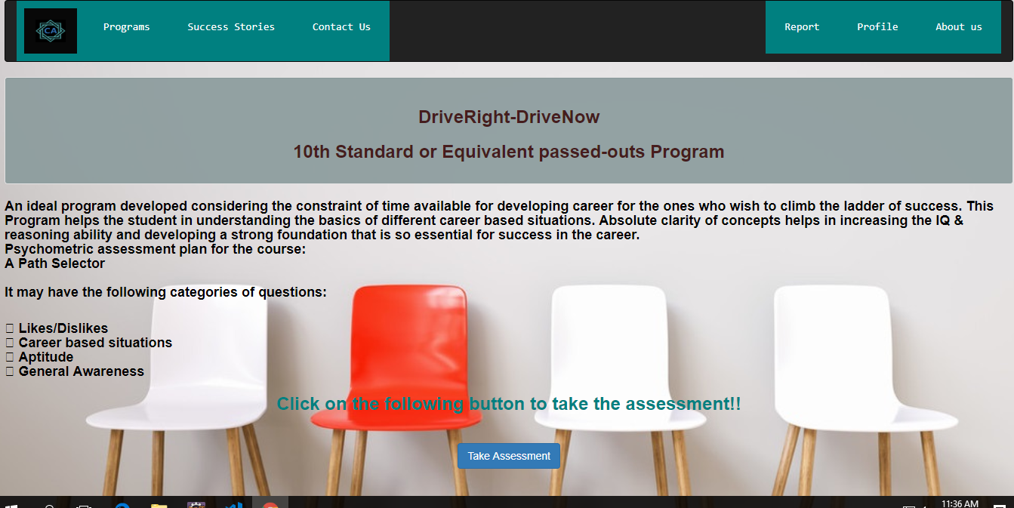





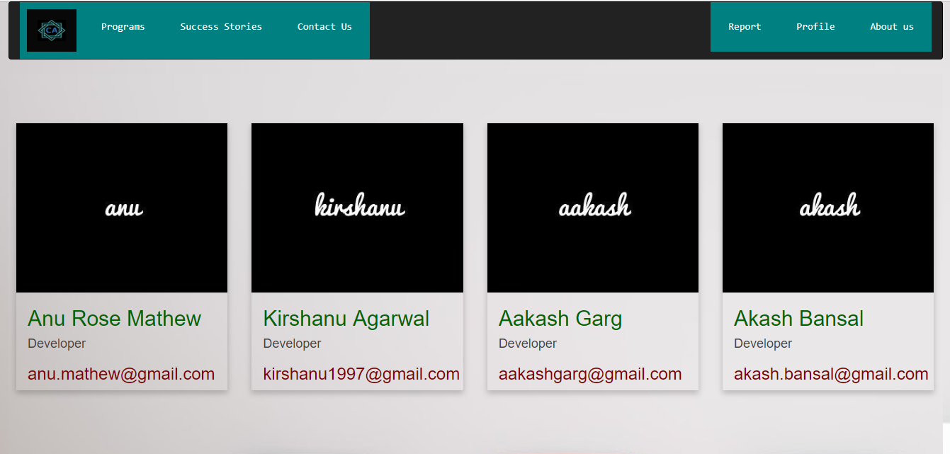

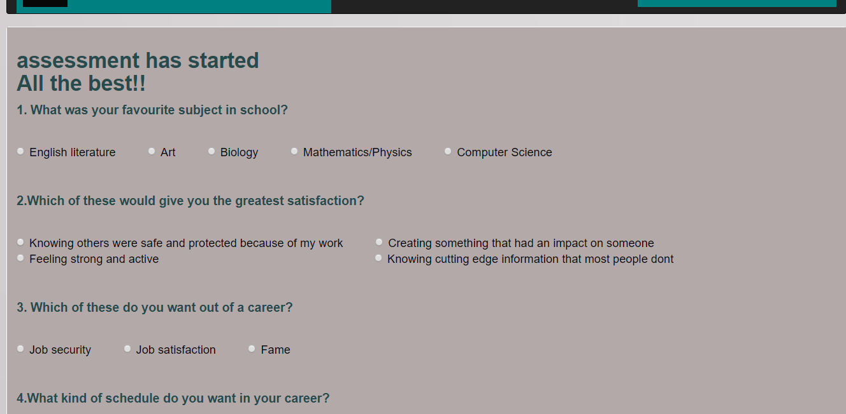

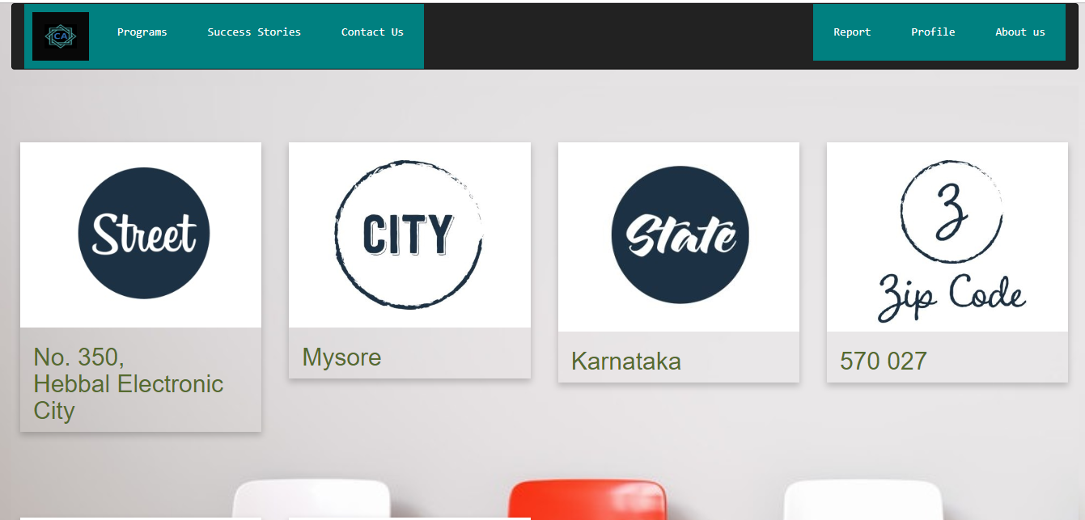

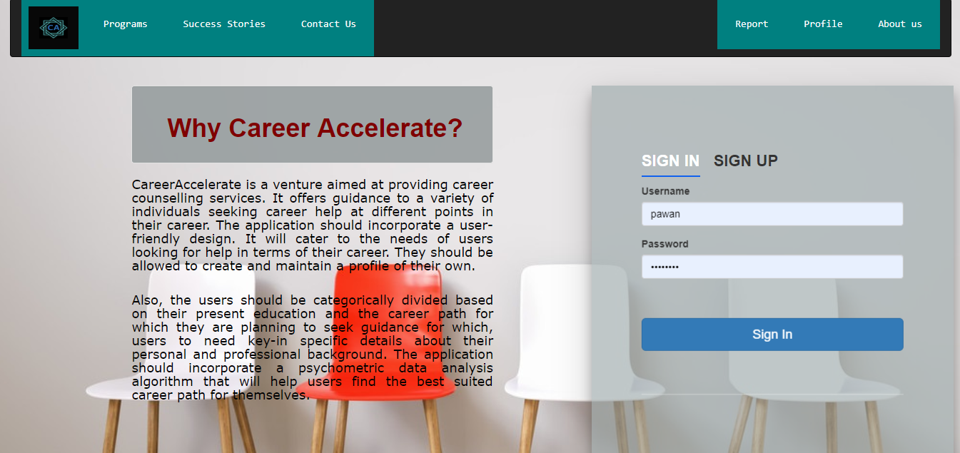

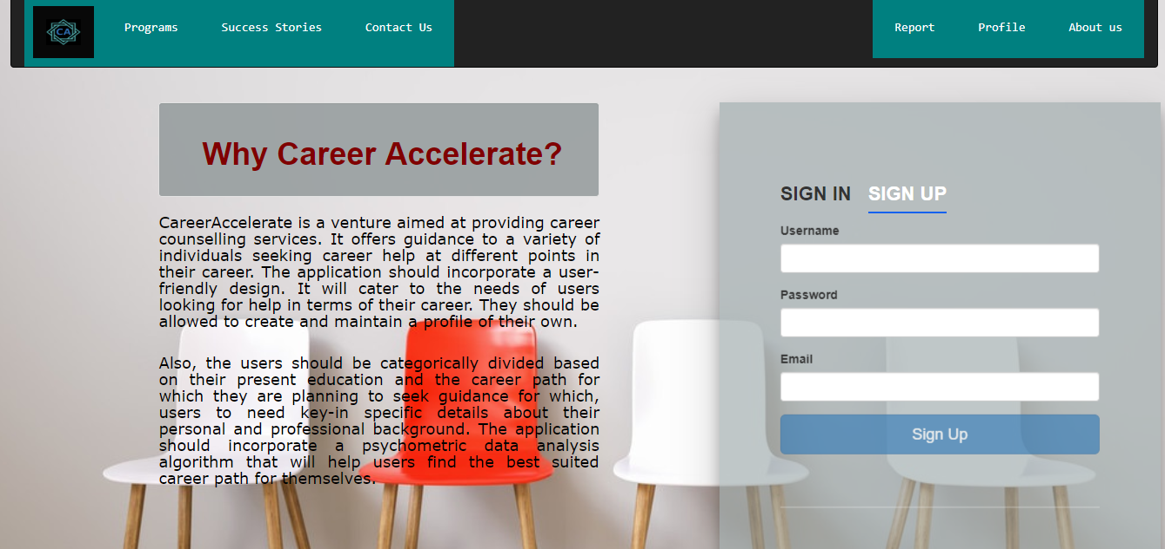

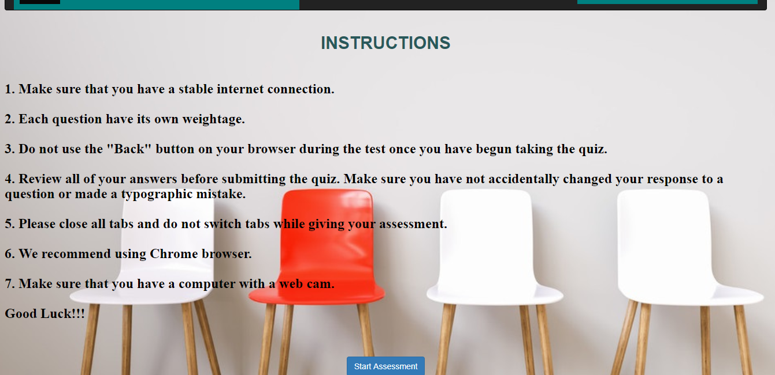





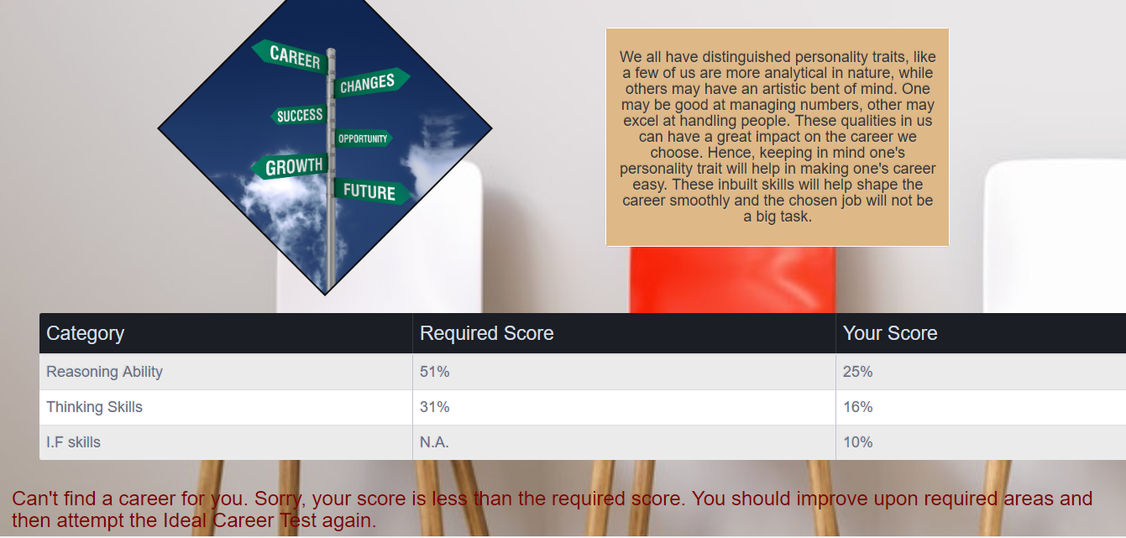

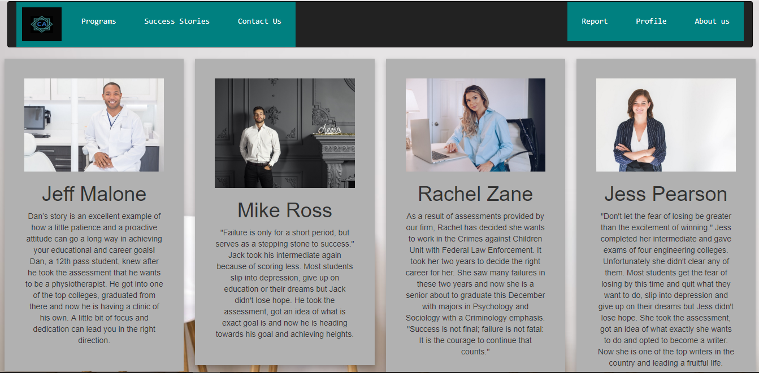

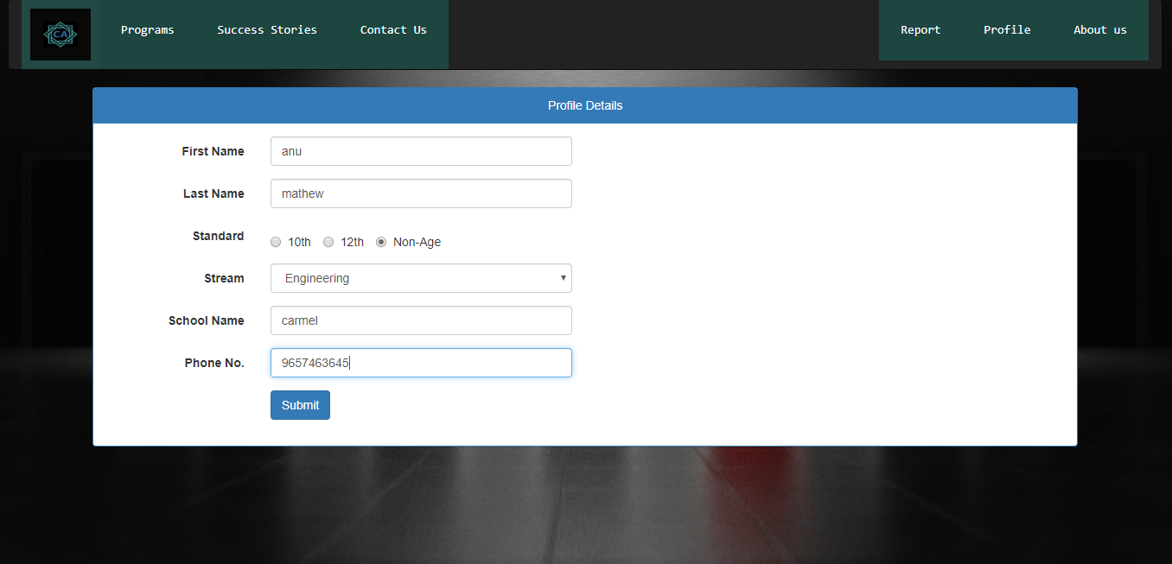

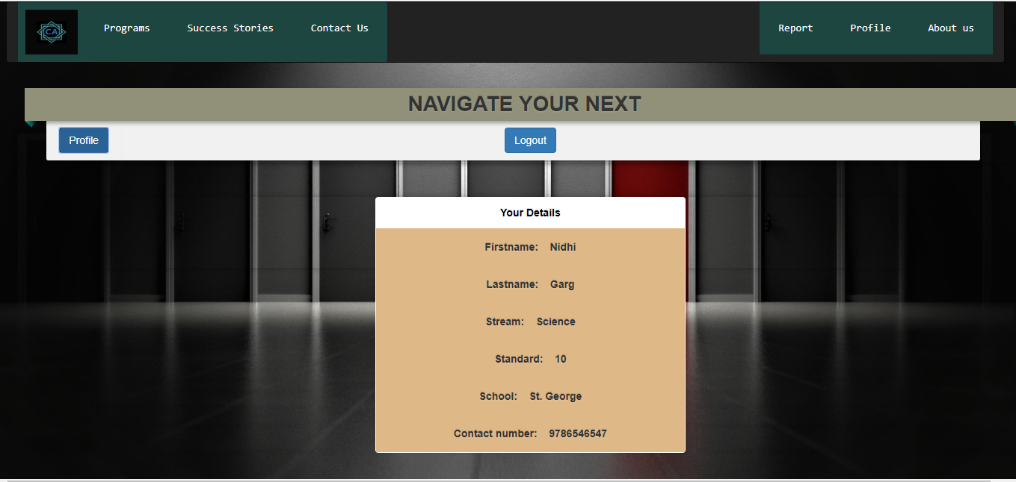

Table

## Input Design

The input is the set of values that is provided by the user to the system.The input design must enable the user to provide the error free input to the system for efficient pro- cessing.The data is fed into the system using simple interactive xml pages.The pages have been supplied with messages so that user can enter data without facing any diffi- culty.The data is validated wherever it requires in the project

The main objectives of the input design are as follows:

* + - * Produce effective method of input
      * Achieve high level accuracy
      * Ensure that the input is acceptable and understood by the user The different types of input data handled by the system are:

## External

They are the primary inputs to the system.The external input is what the user supplies to the system.The user can give different types of external inputs in this project such as registration details,login details etc.

## Internal

When the external inputs are obtained from the user,these inputs are transfered to the system as messages.These messages are captured and handled as input for further pro- cessing.

In this project the input design is done with Android and PHP codes.The external in- puts are the data given to the system by the user.The neccessary external inputs are given to the system by Graphical User Interface(GUI)technology.The GUI system applied to this project enables the user to avoid error and confusion arises while entering the input.

## Output Design

The primary consideration in the design of all output is the information requirement and other objective of the users. It is the most important and direct source of information to the user. A major form of output is a hard copy. Print out should be designed around the output requirements of the user. Each output should be given a specific name or title. The output data is displayed on the visual display unit and output can be redirected to printers and or sorted in a file for later use.

## Database Design

Database is a design to manage large bodies of information. The management of data involves both the definition of structures for the storage information. In addition, the database system must provide for the safety of the information solved, despite system crashes or due to attempts at unauthorized access. For developing an efficient database we have to fulfil certain condition such as controlled redundancy

* + - * Defining the data
      * Inputting the data
      * Locating the data
      * Accessing the data
      * Communicating the data
      * Revising the data

**OBJECTIVES OF DATABASE** In the database design, several objectives are consid- ered such as

* + - * Control of data Integrity
      * Ease of use
      * Control of redundancy
      * Control of security
      * Data independence(Logical and physical)
      * Data storage protection(Record level and Table level)
      * System performance
      * System functions
      * System compatibility

For achieving the above mentioned criterias we have to make use various features that are available with the RDBMS by enforcing integrity constraints, we can ensure data integrity and reduce data inconsistency to a great extent. Recovery from failures can overcome using backup facilities. By using table level as well as row level locking facilities , wecan avoid concurrent access normalize. Another important features of RDBMS is the logical and physical data independence. In addition to security mecha- nism provided by RDBMS, we have provided system password to near system

**NORMALIZATION:**Normalization is the term obtained from the Latin word NORMA which means that square used by the carpenter .Normalization is the process of sim- plifying the relationship between data elements in a record, through normalization a collection of data I a record structure is replaced by successive record structures that

are simpler and can be managed efficiently. While designing the database, we have to implement the concept of normalization to avoid data redundancy in the database. Normalization is carried out for four reasons.

* + - * To structure the data so that any pertinent relationship between entities can be represented.
      * To permit simple retrieval of data in response to query and reports required.
      * To simplify data maintenance procedures such as insertion, deletion and updating.
      * To reduce the need to be structure or reorganize data with new application re- quirements arise.

The major normalization strategies are

* + - * First Normal Form
      * Second Normal Form
      * Third Normal Form
      * Boyce/Codd Normal Form(BCNF)

**FIRST NORMAL FORM:** First Normal Form is achieved when all repeating groups in a record are removed, so that record is of fixed length. A repeating group, reoccurrence of a data item or group of data item within a record indicates another relation.

**SECOND NORMAL FORM:** Second Normal Form is achieved when a record is in first normal form and each item in the record is functionally depend on the primary key for identification. In other words, analyst seeks functional dependency. A data item is functionally dependent of its value is uniquely associated with a specific data item is functionally dependent of its value is uniquely associated with a specific item. To achieve second normal form every column in a table that is not dependent on the primary key of the record should be removed and used to form a separate relation.

**THIRD NORMAL FORM:** Third Normal Form is achieved when all transitive dependencies are removed from a record. That is, if A is functionally dependent on B and B is functionally dependent on C, then A is functionally dependent on C.

**BOYCE/CODD NORMAL FORM(BCNF):** BCNF is often used to distinguish the new 3NF from the old. An attribute possible composite is called as determinant. If other attributes are fully functionally determined this attribute(or on which some other attribute is fully functionally dependent on this attribute).A table is in BCNF , if every determinant is a candidate key. To achieve a table is in BCNF, remove fields which are

fully functionally dependent on a determinant, which is not act as a candidate key.

Login

|  |  |  |
| --- | --- | --- |
|  |  |  |
| Username | Primary key | Varchar2(15) |
| Password | Not null | Varchar2(20) |
| email | Not null | Varchar2(30) |

Profile

|  |  |  |
| --- | --- | --- |
|  |  |  |
| sId | Number(7) |  |
| Firstname | Varchar2(25) |  |
| Lastname | Varchar2(25) |  |
| Schoolname | Varchar2(25) |  |
| Stream | Varchar2(25) |  |
| Standard | Varchar2(25) |  |
| phonenumber | Varchar2(20) |  |
| username | Varchar2(15) | Primary key |

Exam

|  |  |  |
| --- | --- | --- |
|  |  |  |
| Username |  |  |
| Option1 |  |  |
| Option2 |  |  |
| Option3 |  |  |
| Option4 |  |  |
| Option5 |  |  |
| Option6 |  |  |
| Option7 |  |  |
| Option8 |  |  |
| Option9 |  |  |
| Option10 |  |  |
| Optio11 |  |  |
| Option12 |  |  |
| Option13 |  |  |
| Option14 |  |  |
| Option15 |  |  |
| Var1 |  |  |
| Var2 |  |  |
| Var3 |  |  |

# CHAPTER 4 SYSTEM TESTING

Testing is the process of examining the software to compare the actual behavior with that of the excepted behavior. The major goal of software testing is to demonstrate that faults are not present. In order to achieve this goal the tester executes the program with the intent of finding errors. Though testing cannot show absence of errors but by not showing their presence it is considered that these are not present.

System testing is the first Stage of implementation, which is aimed at ensuring that the system works accurately and efficiently before live operations commences. Testing is vital to the success of the system. System testing makes a logical assumption that if all the parts of the system are correct and the goal will be successfully achieved. A series of testing are performed for the proposed system before the proposed system is ready for user acceptance testing.

The purpose of system testing is to identify and correct errors in the candidate sys- tem. Testing is an important element of the software quality assurance and represents the ultimate review of specification, design and coding. The increasing visibility of the software as a system element and the costs associated with a software failure are moti- vated forces for well planned, through testing. Software testing is a critical element of software quality assurance and represents the ultimate quality review of specifications, design and code generation.

Once the source code has been generated, the program should be executed before the customer gets it with the specific intend of fining and removing all errors, test must be designed using disciplined techniques. Testing techniques provides the systematic guidance for designing tests. To uncover the errors in the program behavior function and performance the following steps to be done:

* + - * Execute the integral logic of the software components.
      * Execute the input and output domains of the program to uncover errors

During testing the system is used experimentally to ensure that the software does not fail, i.e., it will run according to the specification and in the way the user expects. Preparation of test data plays n vital role in the system testing. Different set of test data are generated and the system under study is tested using that data. While testing using test data errors are again uncovered and corrected using different testing techniques. System testing was conducted in order to detect errors and for comparing then the final system with the requirement specification report. That is, whether the system meets requirements. During testing the software was executed with a set of test cases and the output of the program for the test cases was evaluated to determine if the program is performing as it was expected to.

Testing presents, an interesting challenge for the software engineer attends to hold software from an abstract concept to an acceptable implementation. In testing engineer creates a series of test cases that occurs when errors are uncovered. Testing is the process of executing a program for finding errors. A good test is one that has high probability of finding an uncovered error. The turn error is used to refer the difference between the actual output of the software and the correct output. Fault is a condition that causes the software to fail to perform its required function. Software reliability is defined as the required function.

Software reliability is defined as the probability that the software will not undergo failure for a specified time under specified condition. Failure is the inability of a system or a component to perform a required function according to its specification. Different levels of testing were employed for software to make an error free, fault free and reli- able. Basically in software testing four type of testing methods are adopted.

## LEVELS OF TESTING

* + - Unit Testing
    - Integration Testing
    - Validations
    - System Testing

## Unit Testing

In this each module is tested individually before integrating it to the final system. Unit test focuses verification in the smallest unit of software design in each module. This is also known as module testing as here each module is tested to check whether it is producing the desired output and to see if any error occurs.

Unit testing is commonly automated, but may still be performed manually. The IEEE does not favor one over the other. The objective in unit testing is to isolate a unit and validate its correctness. A manual approach to unit testing may employ a step-by- step instructional document. However, automation is efficient for achieving this, and enables the many benefits listed in this article. Conversely, if not planned carefully, a careless manual unit test case may execute as an integration test case that involves many software components, and thus preclude the achievement of most if not all of the goals established for unit testing.

We do the unit test in the following modules:

* + - Admin Module
    - Employee Module

## Integration Testing

Integration testing (sometimes called integration and testing, abbreviated I and T) is the phase in software testing in which individual software modules are combined and tested as a group. It occurs after unit testing and before validation testing. Integration

testing takes as its input modules that have been unit tested, groups them in larger aggre- gates, applies tests defined in an integration test plan to those aggregates, and delivers as its output the integrated system ready for system testing. The purpose of integra- tion testing is to verify functional, performance, and reliability requirements placed on major design items.

## Validations

No system could be useful if it does not produce the required output in the specific format. Output testing is performed to ensure the correctness of the output and its for- mat. The output generated or displayed by the system is tested asking the users about the format required by them. Validation is intended to ensure a product, service, or sys- tem results in a product, service, or system that meets the operational needs of the user. For a new development flow or verification flow, validation procedures may involve modeling either flow and using simulations to predict faults or gaps that might lead to invalid or incomplete verification or development of a product, service, or system. A set of validation requirements, specifications, and regulations may then be used as a basis for qualifying a development flow or verification flow for a product, service, or system

## System Testing

System testing of software or hardware is testing conducted on a complete, inte- grated system to evaluate the system’s compliance with its specified requirements. Sys- tem testing falls within the scope of black-box testing, and as such, should require no knowledge of the inner design of the code or logic.

As a rule, system testing takes, as its input, all of the ”integrated” software compo- nents that have passed integration testing and also the software system itself integrated with any applicable hardware system(s). The purpose of integration testing is to detect any inconsistencies between the software units that are integrated together or between any of the assemblages and the hardware. System testing is a more limited type of test- ing; it seeks to detect defects both within the ”inter-assemblages” and also within the system as a whole.